Module 1 Critical Thinking Assignment Explanation

Nathan Rogers
Colorado State University Global
Course Code: CSC506
Professor Farr
04/20/2025

Critical Thinking Assignment Explanation
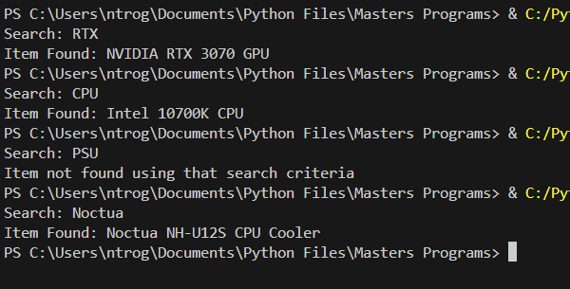
The purpose of this program was to become familiar with a linear search algorithm in specifics to an online marketplace. In a very technologically forward society, every business has their own marketplace to sell their products and databases for those marketplaces are very important to be familiar with.
In the execution picture on the right you can see that it asks for an input similar to a search bar would ask for search criteria. Upon pressing enter the linear search algorithm runs with the search criteria and returns the first item found. If no items are found after searching the whole structure, then it returns with “Item not found using that search criteria.”.
I didn’t have any difficulties with this program as I work with this format of data structure and programming language on a daily basis. Online databases and cloud databases are very familiar to me in fact. In my spare time I run a software company and in each of our mobile applications we utilize Realtime database storage solutions hosted by Google Firebase. This database solution utilizes a NoSQL key-value approach similar to a dictionary or JSON structure. This structure is particularly useful in web applications where data exchange happens between server and webpage. This structure is directly applicable to online marketplaces as well since it is a fast and lightweight data storage solution but can store data in a way that is useful and logical.

